**SOUTH CAROLINA COUNCIL OF CATHOLIC WOMEN**

**2025 Convention Hotel**

[SC Council of Catholic Women's Conference Room Block CLICK HERE](https://www.hilton.com/en/book/reservation/deeplink/?ctyhocn=CHSNCDT&groupCode=CDT907&arrivaldate=2025-03-21&departuredate=2025-03-23&cid=OM,WW,HILTONLINK,EN,DirectLink&fromId=HILTONLINKDIRECT)

**DoubleTree Hotel & Suites Charleston Airport**

**7401 Northwoods Blvd. Charleston SC 29406**

**843 518-6200**

**843 528-6201**

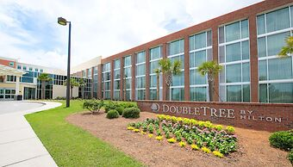

**Location:** The Doubletree by Hilton Hotel & Suites is located centrally between downtown Charleston and Summerville, SC. Charleston Airport is conveniently located on I-26 and 3 miles from I-526 and within minutes of shopping at the Tanger Outlets.

**Amenities**: Include an outdoor pool and 24**-**hour fitness center, complimentary wireless internet access, concierge services and a fireplace in the lobby. 24-hour business center and express check -in.

**Restaurant-The Two Wrights-**features a bar/lounge in the lobby or take advantage of room service. Cooked to order breakfast available daily from 6am to 10 am for a fee.

**Free self-parking is available for all guests.**